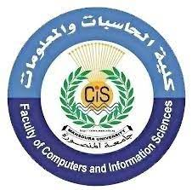 **FCIS MU**

**Names members:**

* Ahmad Gamal Ibrahim Fahim Mazen || Section 1
* Abdallah Magdy Bedear Mattar || Section 4
* Abdelrahman Ahmad Mohamad Elwan || Section 4
* Sherief Magdy Mahmoud Mohamad Elbarbary || Section 3

**The Project Idea: Charity organization**

**Paragraph:**

The idea of ​​the project allows donors to provide what they need to the association, and the needy is able to browse the website or application, provide evidence of his need for this item, choose the classification from the classification list, then choose the item he wants, then the association verifies its credibility through a representative who goes to the needy’s home to confirm..

Engineer: Wafaa Moans

Doctor: Amal Abo_Eleneen

Doctor: Hamdi Henaidy